Project Management System for Platinum Clothing Shop

1. Introduction
   1. Project Description

This project is about database system for Platinum Clothing Shop (Pathein). The main purpose of the project is to computerize a part of the work of a chief executive officer of the Platinum Online Clothing Shop so that the chief executive officer is able to eliminate paperwork. The system helps the chief executive officer avoid mistakes that are likely to be made and errors that are likely to be come out.

The system has many benefits for the chief executive officer and other staffs of the Platinum Online Clothing Shop. One of the best advantages is timesaving. The chief executive officer is able to save much time by using the system instead of using traditional bookkeeping as the system is efficient. One amazing advantages of the system is that the chief executive officer and other staffs are able to access the particular information anytime. However, they need to have appropriate technical knowledge in order to use the system.

One of the advantages of the system is the information is able to access easily at any time. Moreover, the system is efficient and time-saving. The system helps eliminate paperwork, avoid mistakes and errors. As a result of its advantages, it can make the chief executive officer of the Platinum Online Clothing Shop use the system.

* 1. Objectives of the Project

The objectives of the project are as follows.

* To help the chief executive officer in bookkeeping for the Platinum Online Clothing Shop
* To keep the record of the sales list daily
* To store the details of the items available and the information of the salesperson
* To eliminate paperwork in bookkeeping of the sales list for the chief executive officer of the Platinum Online Clothing Shop
* To avoid time-consuming
* To eliminate mistakes that are likely to be made in bookkeeping
* To eliminate errors that are likely to be come out in bookkeeping

1. Project Planning
   1. Problem Statement

* The CEO is having trouble with bookkeeping.
* The CEO does not have enough time needed for bookkeeping.
* Space for storing the paperwork is another matter for the CEO.
* The chief executive officer of the Platinum Clothing Shop needs a computerized data management system for the shop.
  1. Project Constraints
     1. Resources

Seven technical staffs are required for the project.

* + 1. Scope

The expected outcome is the computerized data management system for Platinum Clothing Shop (Pathein).

* + 1. Cost

The maximum cost for the project is 1,500,000 including travel cost.

* + 1. Time

The system should be delivered on 11 March, 2019.

* 1. Requirements
     1. Interface Requirements
* When user want to know information, they assess the database
* The CEO inserts data into the database
* Users use the system to manage data
  + 1. Software Requirements

The software requirements are:

Operation System - Microsoft Windows

Database Server - MySQL 5.5

Design Convention - UML Design

* + 1. Hardware Requirements

The minimum hardware requirements are:

* CPU: Intel Core or Xeon 3GHz (or Dual Core 2GHz) or equal AMD CPU
* Cores: Single (Dual/Quad Core is recommended)
* RAM: 4 GB (6 GB recommended)
* Graphic Accelerators: nVidia or ATI with support of OpenGL 1.5 or higher
* Display Resolution: 1280×1024 is recommended, 1024×768 is minimum.
  + 1. Resources

The minimum resources required are:

* At least 7 technical staffs
* Project manager, developers, analysis, testers and document writers.
  1. Risk Management

After identifying risks, the following risks are found.

**Incorrect Data Risk**

Analyze -The risk is where the users enter incorrect data.

Plan -To define data integrity rules.

Track -A testing is needed to make sure the risk has been controlled.

Control -Correct the deviation and make any necessary amendments.

**Unauthorized User Risk**

Analyze -The risk is where unauthorized user enters the system.

Plan -To define security rules.

Track -A testing is needed to make sure the risk has been controlled.

Control -Correct the deviation and make any necessary amendments.

**Staff Turnover**

Analyze -The risk is where experienced staff leaves the project before it is finished.

Plan -To improve group cohesiveness.

1. Project Scheduling
   1. Work Breakdown

Resource Chart

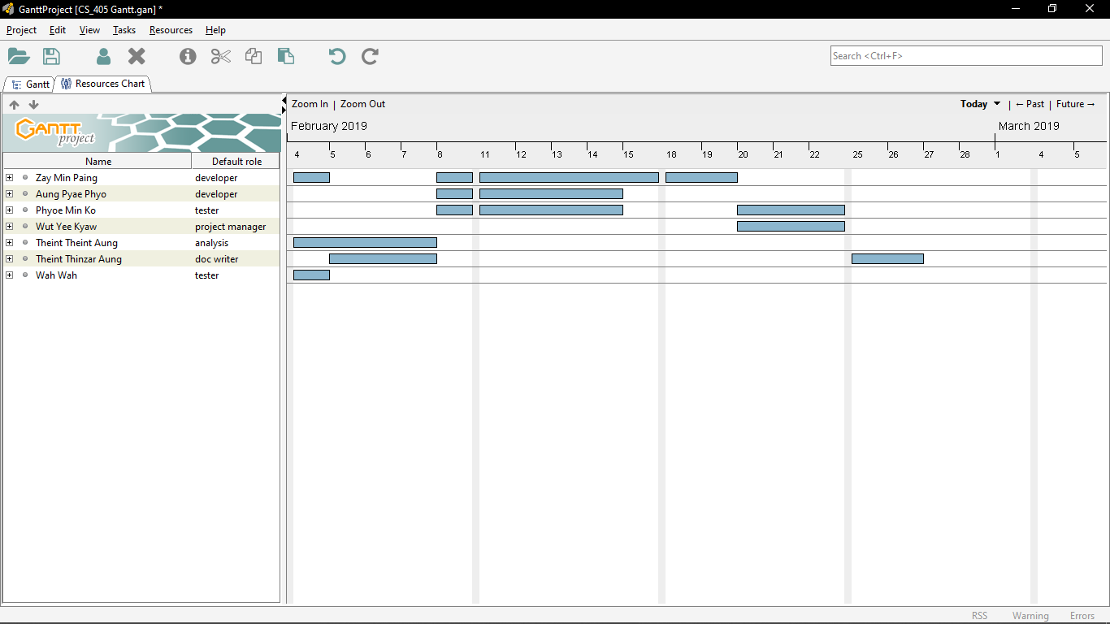

PERT Chart

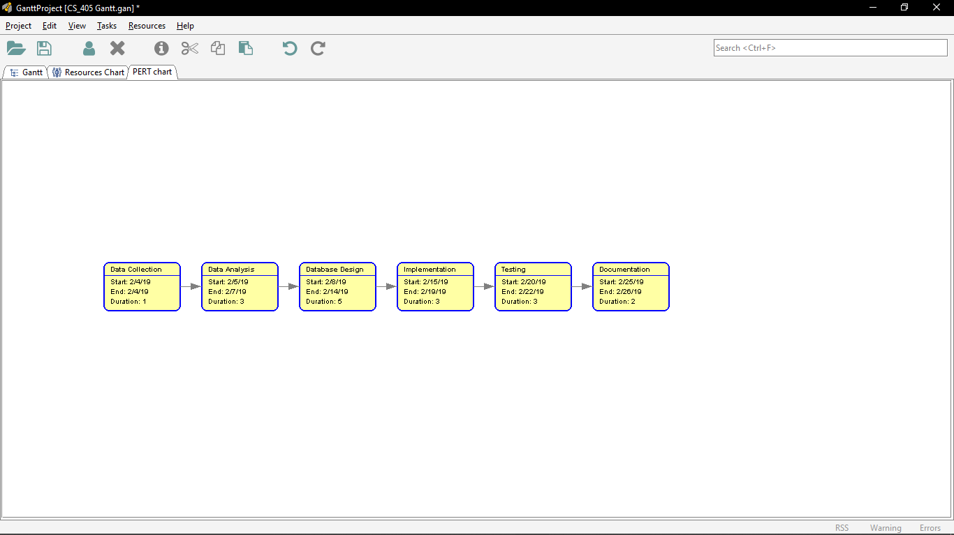

Gantt Chart

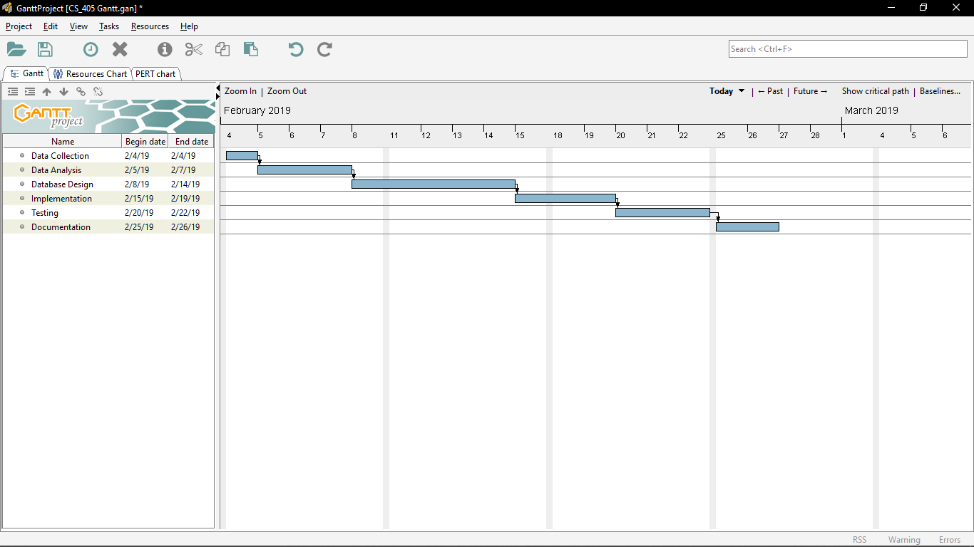

Critical Path

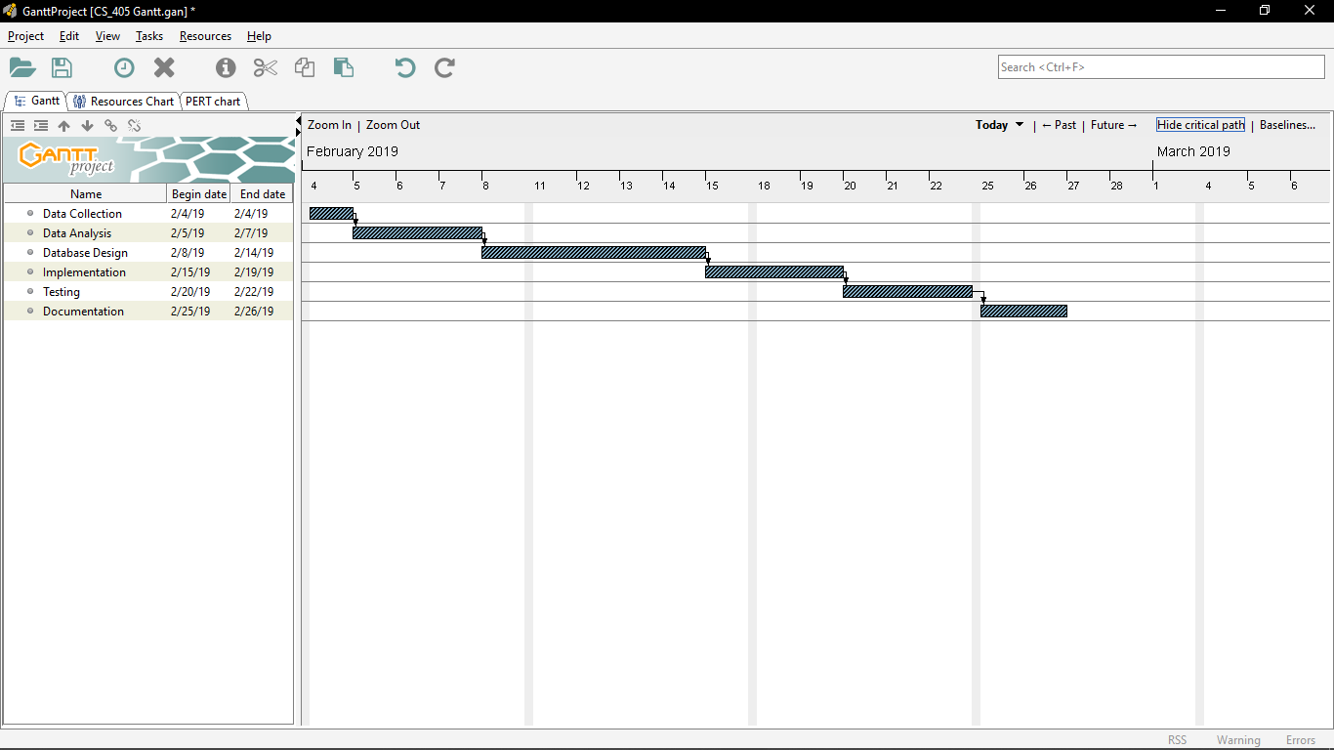

* 1. Context Diagram

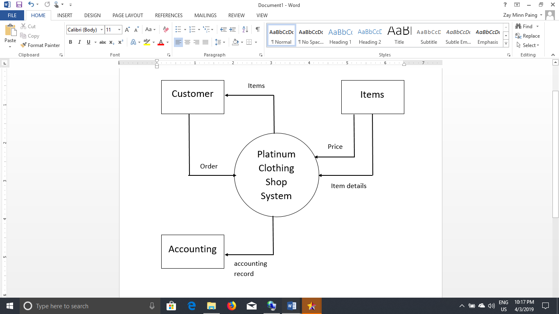

* 1. ER Diagram

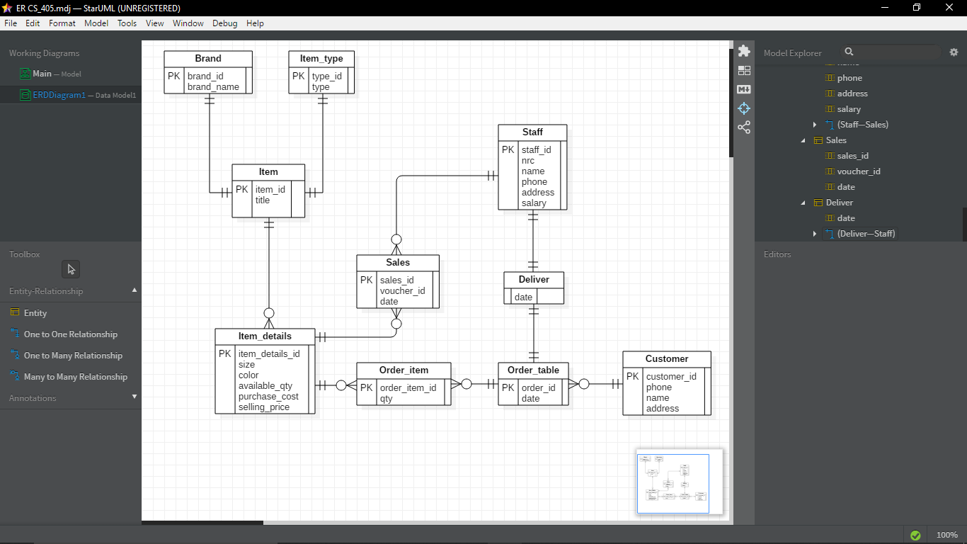

1. Conclusion

This database system is for Platinum Clothing Shop in Pathein. This database system can be used in any other appropriate application like Web Applications, Java Applications, C++ Applications, C# Applications, Android Applications and so on.